**Topics: Confidence Intervals**

1. For each of the following statements, indicate whether it is True/False. If false, explain why.
2. The sample size of the survey should at least be a fixed percentage of the population size in order to produce representative results.

**Ans:-** False, Based on the cases it may vary. As in some of the cases the percentage will be high and in some of the cases the percentage is low.

1. The sampling frame is a list of every item that appears in a survey sample, including those that did not respond to questions.

**Ans:-** False, A sampling frame is a list of all the individuals or units that could potentially be selected for a survey or research study. It is not necessarily a list of every item that appears in a survey sample, and it may or may not include individuals who did not respond to questions or participate in the study.

1. Larger surveys convey a more accurate impression of the population than smaller surveys.

**Ans:-** True

1. *PC Magazine* asked all of its readers to participate in a survey of their satisfaction with different brands of electronics. In the 2004 survey, which was included in an issue of the magazine that year, more than 9000 readers rated the products on a scale from 1 to 10. The magazine reported that the average rating assigned by 225 readers to a Kodak compact digital camera was 7.5. For this product, identify the following:
2. The population  
   **Ans::-** The population = 9000
3. The parameter of interest  
   **Ans:-** The parameter of interest is 7.5
4. The sampling frame  
   **Ans:-** The sampling frame is All readers of the issue where survey was conducted.
5. The sample size  
   **Ans:-** The sample size is 225
6. The sampling design  
   **Ans:-** Voluntary Response.
7. Any potential sources of bias or other problems with the survey or sample **Ans:-** It is possible that only those who were particularly pleased or only who are displeased with the product participated in the survey which can makes the results unreliable.
8. For each of the following statements, indicate whether it is True/False. If false, explain why.
9. If the 95% confidence interval for the average purchase of customers at a department store is $50 to $110, then $100 is a plausible value for the population mean at this level of confidence.

**Ans:-** True

1. If the 95% confidence interval for the number of moviegoers who purchase concessions is 30% to 45%, this means that fewer than half of all moviegoers purchase concessions.

**Ans:-** True

1. The 95% Confidence-Interval for *μ* only applies if the sample data are nearly normally distributed.

**Ans:-** True

1. What are the chances that 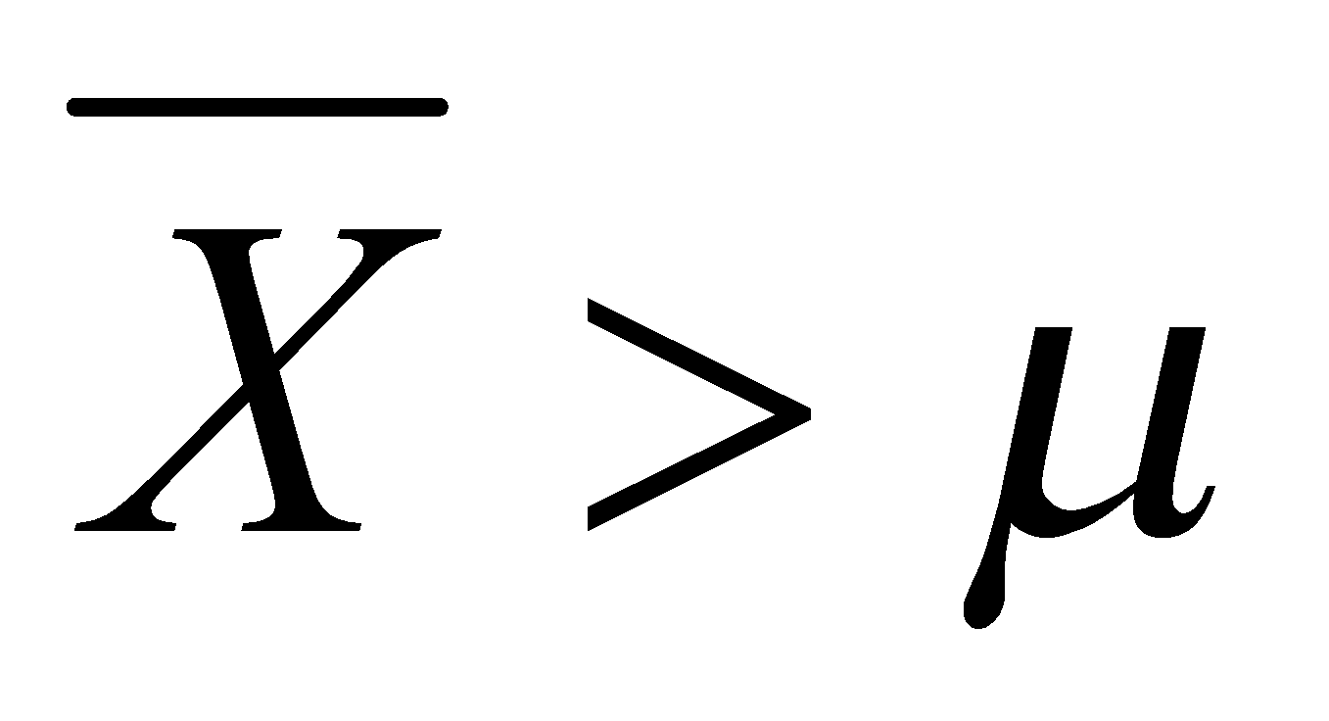?
2. ¼
3. ½
4. ¾
5. 1

**Ans:-** D. 1

1. In January 2005, a company that monitors Internet traffic (WebSideStory) reported that its sampling revealed that the Mozilla Firefox browser launched in 2004 had grabbed a 4.6% share of the market.
2. If the sample were based on 2,000 users, could Microsoft conclude that Mozilla has a less than 5% share of the market?  
   **Ans:-**  No, Microsoft doesn’t conclude that Mozilla has a less than 5% share of the market. As it rejects NULL hypothesis and as pvalue is less than 0.05.
3. WebSideStory claims that its sample includes all the daily Internet users. If that’s the case, then can Microsoft conclude that Mozilla has a less than 5% share of the market?  
   **Ans:-** True, As given in the above data it is 4.6% which is less than 5%
4. A book publisher monitors the size of shipments of its textbooks to university bookstores. For a sample of texts used at various schools, the 95% confidence interval for the size of the shipment was 250 ± 45 books. Which, if any, of the following interpretations of this interval are correct?
5. All shipments are between 205 and 295 books.

**Ans:-** No, All shipments are between 205 and 295 books

1. 95% of shipments are between 205 and 295 books.

**Ans:-** Yes, all shipments are between 205 and 295 books.

1. The procedure that produced this interval generates ranges that hold the population mean for 95% of samples.

**Ans:-** Correct

1. If we get another sample, then we can be 95% sure that the mean of this second sample is between 205 and 295.

**Ans:-** Correct

1. We can be 95% confident that the range 160 to 340 holds the population mean.  
   **Ans:-** Yes, we can be 95% confident that the range 160 to 340 holds the population mean.
2. Which is shorter: a 95% *z*-interval or a 95% *t*-interval for *μ* if we know that σ =s?
3. The z-interval is shorter
4. The t-interval is shorter
5. Both are equal
6. We cannot say  
   **Ans:-** A) The z-interval is shorter

Questions 8 and 9 are based on the following: To prepare a report on the economy, analysts need to estimate the percentage of businesses that plan to hire additional employees in the next 60 days.

1. How many randomly selected employers (minimum number) must we contact in order to guarantee a margin of error of no more than 4% (at 95% confidence)?
2. 600
3. 400
4. 550
5. 1000

**Ans:-** To determine the minimum sample size needed for a given margin of error and confidence level, we can use the following formula:

n=(Z^2*p*q)/(E^2)

where:

n=sample size

Z=Z-score for the desired confidence level (at 95% confidence, Z = 1.96)  
 p=proportion of business that plan to hire additional employees (unknown)

q=proportion of business that do not plan to hire additional employees (1-p)

E=margin of error(4% or 0.04)  
  
 Since, we do not know the proportion of businesses that plan to hire, we can use a conservative estimate of 0.5 for p (assuming that half of businesses plan to hire and half do not). This will gives us the largest possible sample size, which will ensure that the margin of error is no more than 4%.

Plugging in the values, we get:

n=((1.96)^2 *0.5*0.5)/0.04^2

n=600.25

Therefore, we need to contact at least 600 employees to guarantee a margin of error of no more than 4% at 95% confidence level.

1. 600
2. Suppose we want the above margin of error to be based on a 98% confidence level. What sample size (minimum) must we now use?
3. 1000
4. 757
5. 848
6. 543

**Ans:-** From the above formula that :

n=((Z^2)*p*q)/(E^2)

Here, the confidence interval is 98%.

Therefore that the Z-score for that confidence interval is 2.33.  
 Assuming all other parameters same, we get,

n=((2.33^2)*0.5*0.5)/(0.04^2)

we get,

n= 848.26

Therefore, we need to contact at least 848 employees to guarantee a margin of error of no more than 4% at 98% confidence level.

C) 848